Friday, December 11, 2020
2:00 – 3:00 PM
Online through Zoom
Registration Required! (Link Below)

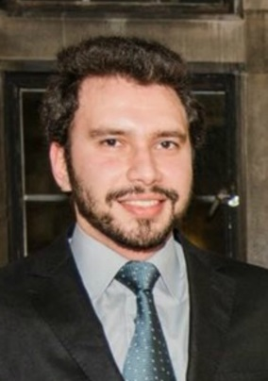
Featured Speakers:
HAMED YASSAGHI
Ph.D. Candidate in Architectural Engineering
College of Engineering
Building Energy and Occupant Thermal Comfort Under Climate Change: Performance, Uncertainties, and Responses (PURe)

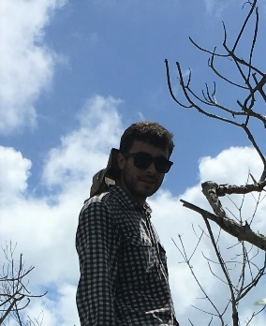
BENOIT BECHADE
Ph.D. Candidate in Biology
College of Arts and Sciences

Catching Bugs in Bugs, Or How to Study Digestion in Tiny Guts

Registration Link Here
For more information, please visit drexel.edu/graduatecollege

